**30 Nov 2018** **The Weekly Bulletin of Rotary Club of Kathmandu Mid-Town** **bc-11.11/018**

|  |
| --- |
| C:\Users\Public\Documents\RIP T1819_EN.png |

District: 3292 Web:www.rotarymidtown.org.np Club Id: 26776

**NOVEMBER IS ROTARY FOUNDATION** **MONTH**

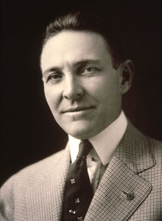

In the words of Arch Klumph: “Money alone does little good. Individual service is

helpless without money. The two together can be a godsend to civilization.” Your

financial resources combined with your time, energy and talent is critical to Rotary’s

mission. 89% of your contribution goes directly to the programs of The Rotary

Foundation while 2% is used for administration and 9% is for fundraising. These

percentages are remarkable among charities across the world. This is why The Rotary

Foundation gets such high marks from organizations that rank charities, such as

Charity Navigator and the Better Business Bureau.

As Rotarians, there is no better place to donate our money. We get to use our own

contributions to do good in the world. PRI P Arch C. Klumph

**Club Meeting # 1465** : 23 Nov 018

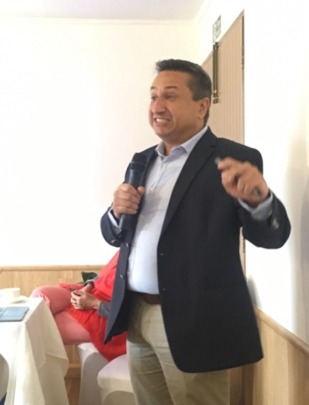 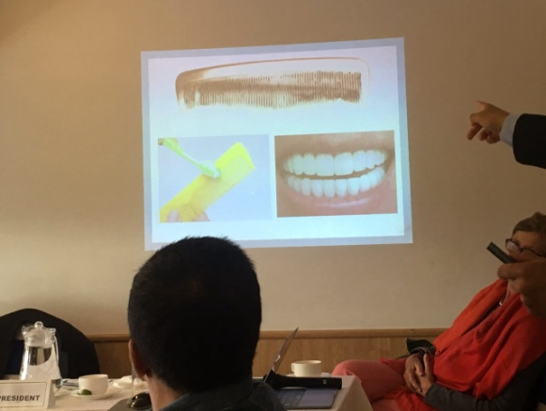 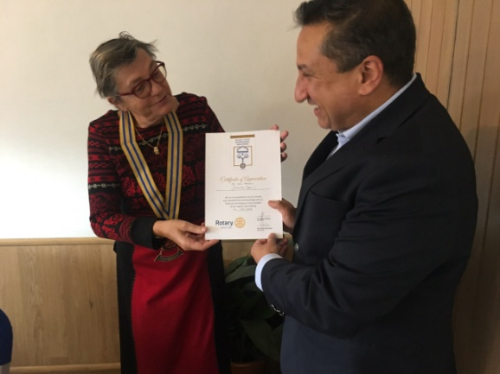

Guest speaker Dr Neil Pandey talking on preventive dentistry, holistic care President Jo handing over a certificate of

and minimally invasive practices. appreciation to the guest speaker.

*Photo courtesy: Rtn Shyam R Thapalia*.

# Weekly Meeting/Program Schedule:

|  |  |  |
| --- | --- | --- |
| Date | Program/ Speaker | Topic of Presentation |
| 7 Dec 2018 | Club Assembly |  |
| 12 Dec 2018 | DG Visit |  |
|  |  |  |

Friday Meeting: 30 Nov

Ms. Christine Donald, Director of Engineering for Development at the University of Strathclyde, Glasgow will be our guest speaker for the day. She is here in the Capital for about a week. Rotary Club of Sterling, Scotland plan to assist in the EQ damaged school rebuilding project at Nuwakot, proposed by the University of Strathclyde. She will give us a background presentation on the University of Strathclyde and the proposed project.

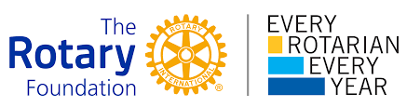

With your help, we can make lives better in your community and around the world

**Why should I donate to The Rotary Foundation?**

Giving works because Rotary works. We are proud that 90.8 percent of donations go straight to supporting our service projects.

**How does The Rotary Foundation use donations?**

Our 35,000 clubs carry out sustainable humanitarian service projects. Using donations like yours, we’ve wiped out 99 percent of all polio cases. Your donations train future peacemakers, support clean water, and strengthen local economies.

**What impact can one donation have on the world?**

It can save a life. A child can be protected from polio with as little as 60 cents. Our partners make your donation go even farther. For every $1 Rotary commits to polio eradication, the Bill & Melinda Gates Foundation has committed $2.

The Annual Fund makes it possible for Rotary clubs to transform lives worldwide. ... The **Every Rotarian, Every Year (EREY)** initiative encourages all Rotary club members to contribute $100 every year to help us reach our goal to support the Rotary Foundation financially each year.

*From Rtn Isabella Khadka for Breakfast Chatter*

**Rotary International Convention, Hamburg:**

REGISTRATION FEES: ONLINE, MAIL, FAX

**Important deadlines:**

**15 December 2018:** Last day for early-registration discount

**31 March 2019:** Last day for preregistration discount

**5 June 2019:** Last day for online registration

28 June - 15 Dec 2018 16 Dec 2018 - 31 Mar 2019 1 Apr - 5 Jun 2019

Rotarian US$ 395 US$ 495 US$ 595

Rotaractor US$ 120 US$ 170 US$ 220

Interactor US$ 20 US$ 30 US$ 40

*Source: Rotary.org*

**First Steps Himalaya:**

**Early Years Education Support Projects**

Durga Aran of First Steps Himalaya visited and made presentations to several rotary clubs during his trip

****

to Scotland. This gave Scottish rotarians an excellent opportunity to learn more about the work of First

Steps Himalaya and how the grants had been utilized.

A new Global Grant commencing March 2019 is planned to support a large school in Chautara, a smaller

school in Kalleri as well as helping to purchase a new project vehicle for the organisation.

FSH was asked to deliver Early Years Education projects in eight schools in Syangja District by The Rotary Club of Kirriemuir, Scotland. This will be a 5 year project working with another Rotary Club in Kathmandu.

FSH has agreed to fund an Early Years Education Project in six schools in Nuwakot District.

FSH board member Nicola Crawford travelled to Nepal in September/ October 2018. Nicola supported the Nepali trainers to roll out a new Early Years Teacher training program which is hands-on and encourages local teachers to engage with their children, create their own learning materials and better manage their classrooms.

**Do you know?**

Rotary Club of Pune, Gandhi Bhavan, District 3131, has set a new Guinness Record with a whopping 23,181 pledges online for organ donation in eight hours. People from 950 cities across the country signed up for the cause. “The recent loss of a close relative due to kidney failure triggered this initiative in me” says the Club President Amruta Deogaonkar.

*More on Rotary News, September 2018*

**Committee Chairs’ Column:** *(This column is for use by chairpersons of 5 permanent committees: Club Administration, Membership, Public Relations, Service Projects, and the Rotary Foundation)*

**Members’ Corner:** *(This column is for Club members to express anything they would like in matter of Club activities, Club administration, Club issues or on Breakfast Chatter, or on anything else that would be of interest to fellow members.)*

**A THOUGHT FOR TODAY:**

**Live in such a way that if someone spoke badly of you, no one would believe it !**

On Lighter Side:

It is common practice to expect new Rotarians to give a talk to their fellows about themselves, their early life, their profession and the job they do.

Later in Rotary life the Rotarian is often expected to fill the speaker diary by giving a talk which is NOT connected with his work. A hobby such as stamp collecting or model trains would be a good example. Fred arrived at the meeting of his Rotary club but did not know that he was the speaker for the evening and that was not a "Job Talk".   
He was not prepared. During the meal he thought about a subject.

When he was announced he spoke about sex. He kept his talk interesting. It was a success.

When he arrived home, Mary, his wife, asked "How was the meeting?"

"It was a good meeting" he said.

"Who was the speaker?" she continued.

"I was the speaker" he replied.

"What did you speak about?"

Now he could see trouble looming! "Sailing" he lied.

The next morning Mary was on shopping and visited the grocer who was also a Rotarian.

"Fred gave a wonderful talk last night." he said.

"Yes" said Mary, "but I just don't understand why he chose the subject. The first time he did it he was sick and the second time his hat blew off".

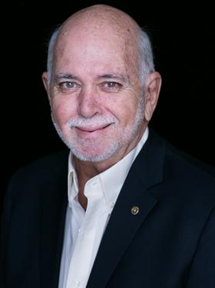

Sustainability has become our watchword in Rotary. We want the good we do to last. We

want to make the world a better place. Not just here, not just for us, but everywhere, for

everyone, for generations..

**RI President Barry Rassin**

Please send information on club activities, progress reviews on service projects, relevant photos etc to:

BC Editor: RR Shrestha email: rryesrr@gmail.com

## 30 Nov 2018 The Weekly Bulletin of Rotary Club of Kathmandu Mid-Town bc-11.11/018